Low Level Design (Add New hotel)

Project Code | Team3
Project Name | Hotel Management System

Prepared/Modified by | Role | Date of Preparation
Reviewed by | Role | Date of Review
Approved by | Role | Date of Approval
 | Training Manager
Circulation List |  | Version Number of the template:1.0
Version Number | 1.4

Table of Contents

1. Description Of The Unit 3
2. References 4
3. Dependencies / Assumptions 5
4. Class Diagrams 6
5. Sequence Diagrams 7
6. Design Components 8
6.1 List Of UI Components 8
6.2 List Of Design Classes 8
7. Re-Usable Routines/Components 9
8. Messages 10
9. Configuration Files 11
10. Crud Matrix Table 12
11. Data Mapping Matrix 13
12. Action Flow Matrix 14
13. Stored Procedures 15
14. Program Specification / Pseudo Code 16
REVISION HISTORY OF THE WORK PRODUCT 17

Description Of The Unit

The Add New Hotel is basically used by the admin of the system to add a new hotel to the database. On clicking the Add link under the ‘Hotel Management’ column name, the admin will be navigated to the addHotel page where he can view the form regarding filling details of the hotel.After that admin has to fill details of the hotel as asked in the form.On clicking the ‘Save’ button given below in the form, all the entered details will be saved in the database in the hotel table. There is a link provided on the AddHotel page named as ‘Logout’ clicking on which admin is logged out and he has to login again for performing further operations.

References

Reference | Description
Repository reference | https://IGTEBLRSVNTNG.igatecorp.com/svn/oct3_Team1
Class Diagram | /Project Documents/Design Documents/HLD/Class Diagrams
URS | /Project Documents/Requirements/Case Study/Ecommerce-grp1 and grp3.doc
UTP | /Project Documents/Test Plan /UTP /Test Cases/AddToCart/ UTP_AddToCartModule.xls
DB Design | NA

Dependencies / Assumptions

Dependencies:
Add new hotel module depends on the Login module in such a way that, the admin is able to add a hotel only when he is logged in.
If the admin is not logged in then he/she will be asked to login.

Assumptions:
Admin id and passwords are given in constant java file from which they are fetched in HotelController java file.

Class Diagrams

Class Diagram

Sequence Diagrams

Sequence Diagram
NA

Design Components

List Of UI Components

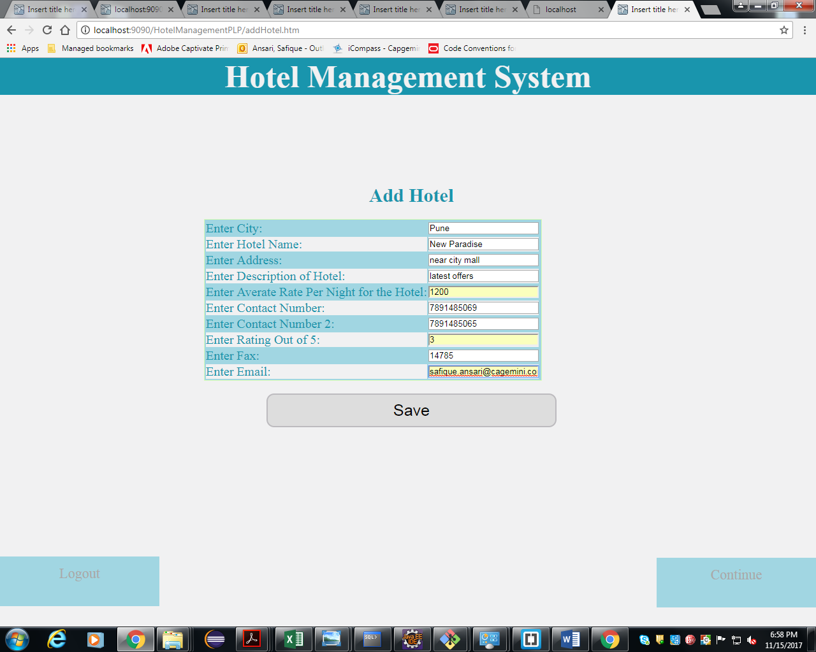

List Of Design Classes

Sr. No. | LLD Name | Class Name | Method Name | Method Description
1 | AddNewHotel | Hotels | Appropriate getters and setters methods | Getters retrieve the property values and setters set the property values
2 | AddNewHotel | HotelController | public String addHotel(Model model)  public String addHotelImpl (Model model,@ModelAttribute("hotel") @Valid Hotels hotel, BindingResult result)  public String redirectToHome() | Sets the model attribute ‘hotel’ and pass this attribute to the addHotel.jsp page for storing details of hotel.So it Navigates to AddHotel page.  Takes details from addHotel page and validates them according to validations in bean class and navigates to Admin page after that.  On clicking the “Logout”, this method of controller is called that redirects to the home page.

Re-Usable Routines/Components

Re-Usable Routines/Components

- CSS files
- Constant Java class
- QueryMapper Java class

8. MESSAGES

#. | Type | Message Text
M1 | Error | Enter valid Pattern ex:tajHotel
M2 | Error | Enter valid Pattern ex:tajHotel
M3 | Error | Enter valid Pattern ex:AC
M4 | Error | It should be a number
M5 | Error | Phone no. must be 10 digits
M6 | Error | Phone no. must be 10 digits
M7 | Error | Range is 1-5
M8 | Error | It Should have five digits only
M9 | Error | Enter valid Email Ex:abc@gmail.com
M10 | Information | Hotel Added Successfully!!!

9. CONFIGURATION Files

File Name | Path | Description
Web.xml | /HotelManagementPLP/WebContent/WEB-INF/ | To configure the bean properties.
Dispatcher-servlet.xml | /HotelManagementPLP/WebContent/WEB-INF/config/ | To configure the request mapping and view resolver.
jpaContext.xml | /HotelManagementPLP/resources/ | Add persistance annotation bean post processor to inject persistence context into entity manager factory.

Crud Matrix Table

# | Table Name | Create | Read | Update | Delete
NA | NA | NA | NA | NA | NA

Data Mapping Matrix

Sr. No. | Screen Label | Field Source | Field Type | Data Type | Max Length | Data Flow | Mandatory
1 | Enter City: | NA | Label | NA | NA | UI | NA
2 | city | Hotel.city | Textbox | Varchar2 | 10 | UI → D  D → UI | Yes
3 | Enter Hotel Name: | NA | Label | NA | NA | UI | NA
4 | hotelname | Hotel.hotel_name | Textbox | Varchar2 | 20 | UI → D  D → UI | Yes
5 | Enter Address: | NA | Label | NA | NA | UI | NA
6 | address | Hotel.address | Textbox | Varchar2 | 50 | UI → D  D → UI | Yes
7 | Enter Description of Hotel: | NA | Label | NA | NA | UI | NA
8 | description | Hotel.description | Textbox | Varchar2 | 50 | UI → D  D → UI | Yes
9 | Enter Average Rate per Night For the Hotel: | NA | Label | NA | NA | UI | NA
10 | avgRatePerNight | Hotel. avg_rate_per_night | Textbox | Number | 10 | UI → D  D → UI | Yes
11 | Enter Contact No: | NA | Label | NA | NA | UI | NA
12 | phone1 | Hotel.phone_no1 | Textbox | Varchar2 | 10 | UI → D  D → UI | Yes
13 | Enter Contact No2: | NA | Label | NA | NA | UI | NA
14 | phone 2 | Hotel.phone_no2 | Textbox | Varchar2 | 10 | UI → D  D → UI | Yes
15 | Enter Rating out of 5: | NA | Label | NA | NA | UI | NA
16 | rating | Hotel.rating | Textbox | Number | 1 | UI → D  D → UI | Yes
17 | Enter Fax: | NA | Label | NA | NA | UI | NA
18 | fax | Hotel.fax | Textbox | Varchar2 | 15 | UI → D  D → UI | Yes
19 | Enter Email: | NA | Label | NA | NA | UI | NA
20 | email | Hotel.email | Textbox | Varchar2 | 15 | UI → D  D → UI | Yes
21 | Save | NA | Button | NA | NA | UI | NA
22 | Logout | NA | Link | NA | NA | UI | NA

Legend
D → UI (Database to User Interface)
UI → D (User Interface to Database)
UI (User Interface Only)

Action Flow Matrix

Sr. No. | Action | Description | Process
1 | On click of “Save” button | Allows the admin to store the entered details into the database. | The admin is navigated to the same page with the message “Hotel Added Succesfully !!!” on the top.
2 | On click of “Logout” Link | Logs out the admin | The admin is navigated to the Homepage where he has to login again to perform any operations.

Stored Procedures
# | Stored Procedure Name  (with Description) | Input/Out Parameters | Type | Size
1. | NA | NA | NA | NA

Program Specification / Pseudo Code

14.1 <ACTION: Add CLICK>

Pseudo Code:
- Client Side Scripting:
None

- Server Side Scripting:
BEGIN

IF admin is not logged in
Navigate to LoginPage

IF Admin is logged in

Call addHotel(Model model)
Send ‘hotel’ attribute to addHotel page.
Enter all the details in the form.
Call public String addHotelImpl (Model model,@ModelAttribute("hotel") @Valid Hotels hotel,
BindingResult result) method in the controller class.

IF any validation error occurs
Print respective messages against that option(M1-M10)

END

14.2 <ACTION: Save_CLICK>
Pseudo Code:
- Client Side Scripting:
None

- Server Side Scripting:
BEGIN
IF Save button is clicked
Details Stoted in Database.

IF saved successfully
Print Message M10
END

14.3 <ACTION: Logout_CLICK>

Pseudo Code:
- Client Side Scripting:
None

- Server Side Scripting:
BEGIN
IF logout link is clicked
Call redirectToHome() in the HotelController class
Navigate to HomePage.
END

REVISION HISTORY OF THE WORK PRODUCT

# | Date | Version # | Section Changed | Details of changes made | Approved By
1 | 16/12/2013 | 1.0 | LLD prepared | N/A | Uma M Ponniamman
2 | 17/12/2013 | 1.1 | Reusable components,  Pseudo Code. | Unwanted Reusable components removed.  More specific control flow specified. | Uma M Ponniamman
3 | 17/12/2013 | 1.2 | Designed Classes,  Reusable components,  Reference | The Controller’s name is changed to ‘EshopController’.  Reusable Components added.  File name with relative path is added in the references section. | Uma M Ponniamman
4 | 20/17/2013 | 1.3 | Designed Classes,  Pseudo code | The method names in the designed class table and pseudo code are changed as per the class diagrams. | Uma M Ponniamman
5 | 24/12/2013 | 1.4 | Configuration files,UI Components | Paths of the configuration files is updated and UI components(Screen Shots) added. | Uma M Ponniamman

